**Name: Anish Ashok Sharma Sap id: 60003220045**

**Branch: Information Technology Div: D/IT1**

**Course**: **Object Oriented Programming using Java**

# Experiment no. 6

Aim: To implement Constructors and constructor overloading

**Problem Statement 1:**

WAOOP to count the no. of objects created of a class using constructors.

Code:

Code:

class ObjectCount

{

static int count=0;

ObjectCount()

{

count++;

}

}

class Object

{

public static void main(String[] args)

{

ObjectCount obj1=new ObjectCount();

ObjectCount obj2=new ObjectCount();

ObjectCount obj3=new ObjectCount();

System.out.println("No of object is "+ObjectCount.count);

}

}

Output :

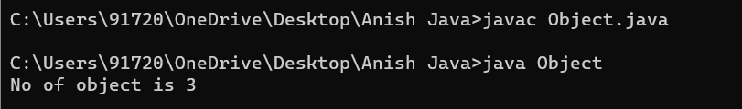

**Problem Statement 2:**

WAP to display area of square and rectangle using the concept of overloaded constructor (use parameterized, non-parameterized and copy constructor).

Code:

import java.util.*;

class AreaRectangle

{

int l;

int b;

AreaRectangle()

{

l=4;

b=8;

System.out.println("Area of rectangle(Default constructor):"+(l*b));

}

AreaRectangle(int l,int b)

{

System.out.println("Area of rectangle(Parameterized constructor):"+(l*b));

}

AreaRectangle(AreaRectangle obj)

{

obj.l=5;

obj.b=9;

System.out.println("Area of rectangle(Copy constructor):"+(obj.l*obj.b));

}

}

class AreaConst

{

public static void main(String[] args)

{

AreaRectangle obj1=new AreaRectangle();

AreaRectangle obj2=new AreaRectangle(7,8);

AreaRectangle obj3=new AreaRectangle(obj2);

}

}

Output:

